Adaptive payments

(sender and receiver can have any type of account but website owner must have business account)

Types:a

Simple -Tipping system

Parallel- sponsors

Payment needs approval

types of approvals:

explicit which means a user will have to login to his paypal account to approve a payment

Preapproved payments: means the user will have to preapprove all payments for our website(better option)

for preapproval, the sender has to login to his paypal account once for setting up preaprrovals

preapproval payments require us to take permission from paypal.com

Explicit approval payment flow diagram:

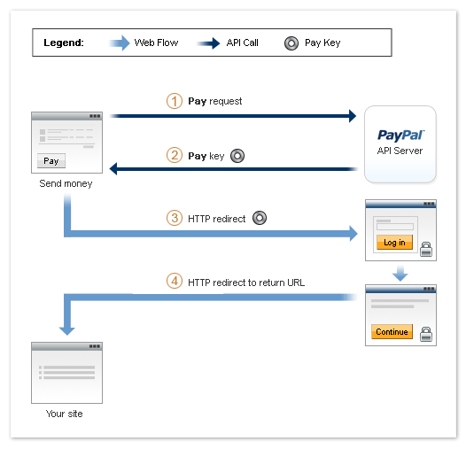

Fee payment

This is used to determine the person who shall pay the transaction fees

In our case, both the receivers (I.e., the memer and Meagl) shall pay the fees

Receiver pays the fee

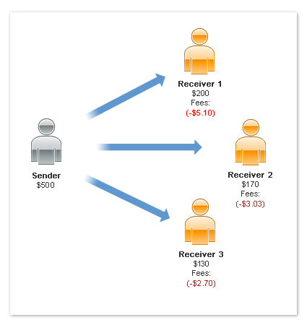

Remittance Fees for International Payments(US to India)

This is a fee that we are required to pay if transferring money from US to other countries

It is not applicable for money transfers below $15

Please check